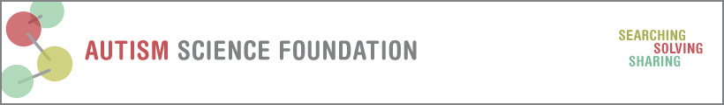
Fellowship 1 year Progress Report

Thank you for taking the time to tell ASF more about your project and the science that will take place after your funding period. If you have little to report, don’t worry, we will be reaching out to you in the future as your career progresses.

Grantee Name:
Mentor Name:
Grant Title:
Sponsoring University:
Grant period dates:
Please provide two emails where you can be reached, one should be a permanent emaila ddress:

- What are the main results of your research so far? Please explain it as you would be talking to a non-scientist, as this section may be reproduced on our website.

- What were some of the negative findings of your research – in other words, what did you NOT find that you expected to find?

- How have the results of your research been disseminated to other scientists so far? List and detail all peer reviewed publications, presentations, scientific conferences, book chapters, etc.

- How have the results of your research been disseminated to the public (list all press releases, public presentations, television, radio, internet, etc.) Do not include presentations at academic meetings, they belong above.

- Was this the first-autism related grant you received?
- As a result of this grant, are you more, less or equally likely to continue in the field of autism research?
  - If more – will you continue with this line of research or will you study other topics?

  - If less – what are your future plans?

- Was this grant useful in obtaining additional funding from either public or private sources? List any funding so far that was obtained as a result of this grant. This also may include grants obtained by your mentor as a result of your research.

- Please describe your training experience. What did you do? What did you learn? What techniques were you exposed to? What communities did you interact with?

- Did this grant—
- Develop your idea into something that will be pursued further? Yes/No
(it is OK to say NO here. But if no, please explain)

- Inform your strategy or thinking for a future grant? Yes/No

If yes, how?

- Result in improved methods of risk assessment related to prevention or earlier, more effective intervention? Yes/No

If yes, please describe:

- Facilitate an individualized/personalized approach to treatment? Yes/No

If yes, please describe:

- Assist in the translation of basic discoveries into potential methods of diagnosis or treatment? Yes/No

If yes, please explain:

- Empirically validate an intervention strategy? Yes/No

- Facilitate the dissemination or implementation of a health or education related service into a broader community setting? Yes/No
If yes, how?

- Please share any ideas regarding how the Autism Science Foundation can improve its grant programs.

