Research Opportunity

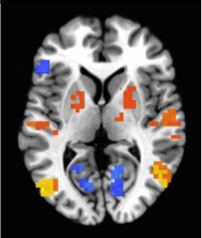

*What does participating involve?*

The total time to participate is about 3-6 hours and can be completed over 1-2 visits to Washington University School of Medicine. Study components include:

1. Answering questionnaires related to social interaction, daily life, and cognition
2. Completing the Autism Diagnostic Observation Scale (ADOS)
3. An MRI scan lasting approximately 45 minutes in which you will watch images or listen to sounds

Participants receive $80 or more for completing all activities (depending on the length of activities).

*Interested in Participating?*

Contact the study coordinator:

Puneeth Nallan Chakravartha

314-273-7577

[puneeth@wustl.edu](mailto:puneeth@wustl.edu)

*What are we studying?*

Many individuals with autism struggle to perceive another person’s emotional state based on their facial expressions, which can complicate social situations. By comparing MRI and eye-tracking data from individuals with and without autism, we hope to understand how the brain processes information related to facial recognition and how that information might be processed differently for individuals with autism.

*SEEKING*

Adults (18+) with autism

This is a research study led by **Shuo Wang, PhD** at Washington University in St. Louis.

<https://sites.wustl.edu/wanglab/>