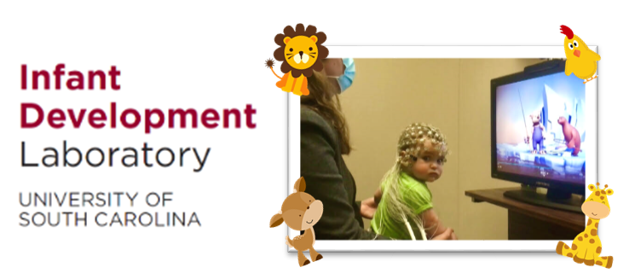
The Infant Development Lab at UofSC is currently recruiting infants between 10 and 12 months of age for a study investigating how infants process faces.

Your participation will take about 45 minutes up to 2 hours per visit where we will learn about developing brain and cognitive abilities using EEG and MRI. You will be able to see pictures of your baby’s brain and their brain activity in real time!

After participation, you will be compensated with $30 up to $150 and UofSC t-shirt in your infant size.

Are you curious to know more about what we do in the lab?
Click the button below to submit your request. You can also contact us at uscinfantlab@sc.edu
Participate
Sincerely,
USC Infant Development Laboratory
University of South Carolina

